Under California Proposition 218, the owner of a parcel(s) may submit a protest. If a tenant pays the water and/or sewer fees, then it is the responsibility of the property owner to provide tenants with this notice of proposed rate changes. Protests must be in writing and filed with the District prior to close of the public hearing on November 18, 2025. Written protests may be hand delivered to the District at our local office, or by email. (located on the back of pamphlet) Written protests must include: Full Name, Service address, signature of the person protesting and clearly state that it constitutes a protest of the proposed new water or sewer rates. A separate protest must be filed to protest the proposed new water rates or the proposed new sewer rates.  Only one protest may be filed per parcel or service address. One protest for water rates, and one protest for sewer rates will be accepted. If a majority of property owners and/or the tenants of the property whose property receives water services file valid written protests prior to the close of the public hearing on November 18, 2025, the new proposed water rates will not be approved. If a majority of property owners and/ or tenants of the property whose property receives sewer services file valid written protests prior to the close of the public hearing on November 18, 2025, the proposed new sewer rates will not be approved.  Under California Government Code section 53759, there is a 120-day statute of limitations for challenging any new, increased, or extended fee or charge. This statute of limitations applies to the water and sewer rates proposed in this notice
  Pursuant to Government Code section 53759.1, subdivision (c)(2), the District has posted at herlongpud.com the written basis for the new rates, including a copy of the District’s cost of service report. Additionally, the written basis will be mailed or emailed to any person upon request by contacting the District office at (530) 827-3150
  About Us
  At Herlong Public Utility District, our mission is to provide safe drinking water that meets or exceeds all of the State and Federal Government standards; maintain a water reclamation plant that disposes of waste in an effective and efficient manner and produces reclaimed water. The District will provide these services as economically as possible.
  Contact Us
  Phone: (530) 827-3150
  Web: herlongpud.com
  Emails:
  Sandy Seifert- Raffelson- GM
  sandy@herlongpud.com
  Brianna Rockey- Finance Manager
  brianna@herlongpud.com
  Barbara Lee- District Clerk
  office@herlongpud.com
   |  | Herlong Public Utility District  PO Box 115  447-855 Plumas St.  Herlong, CA 96130
  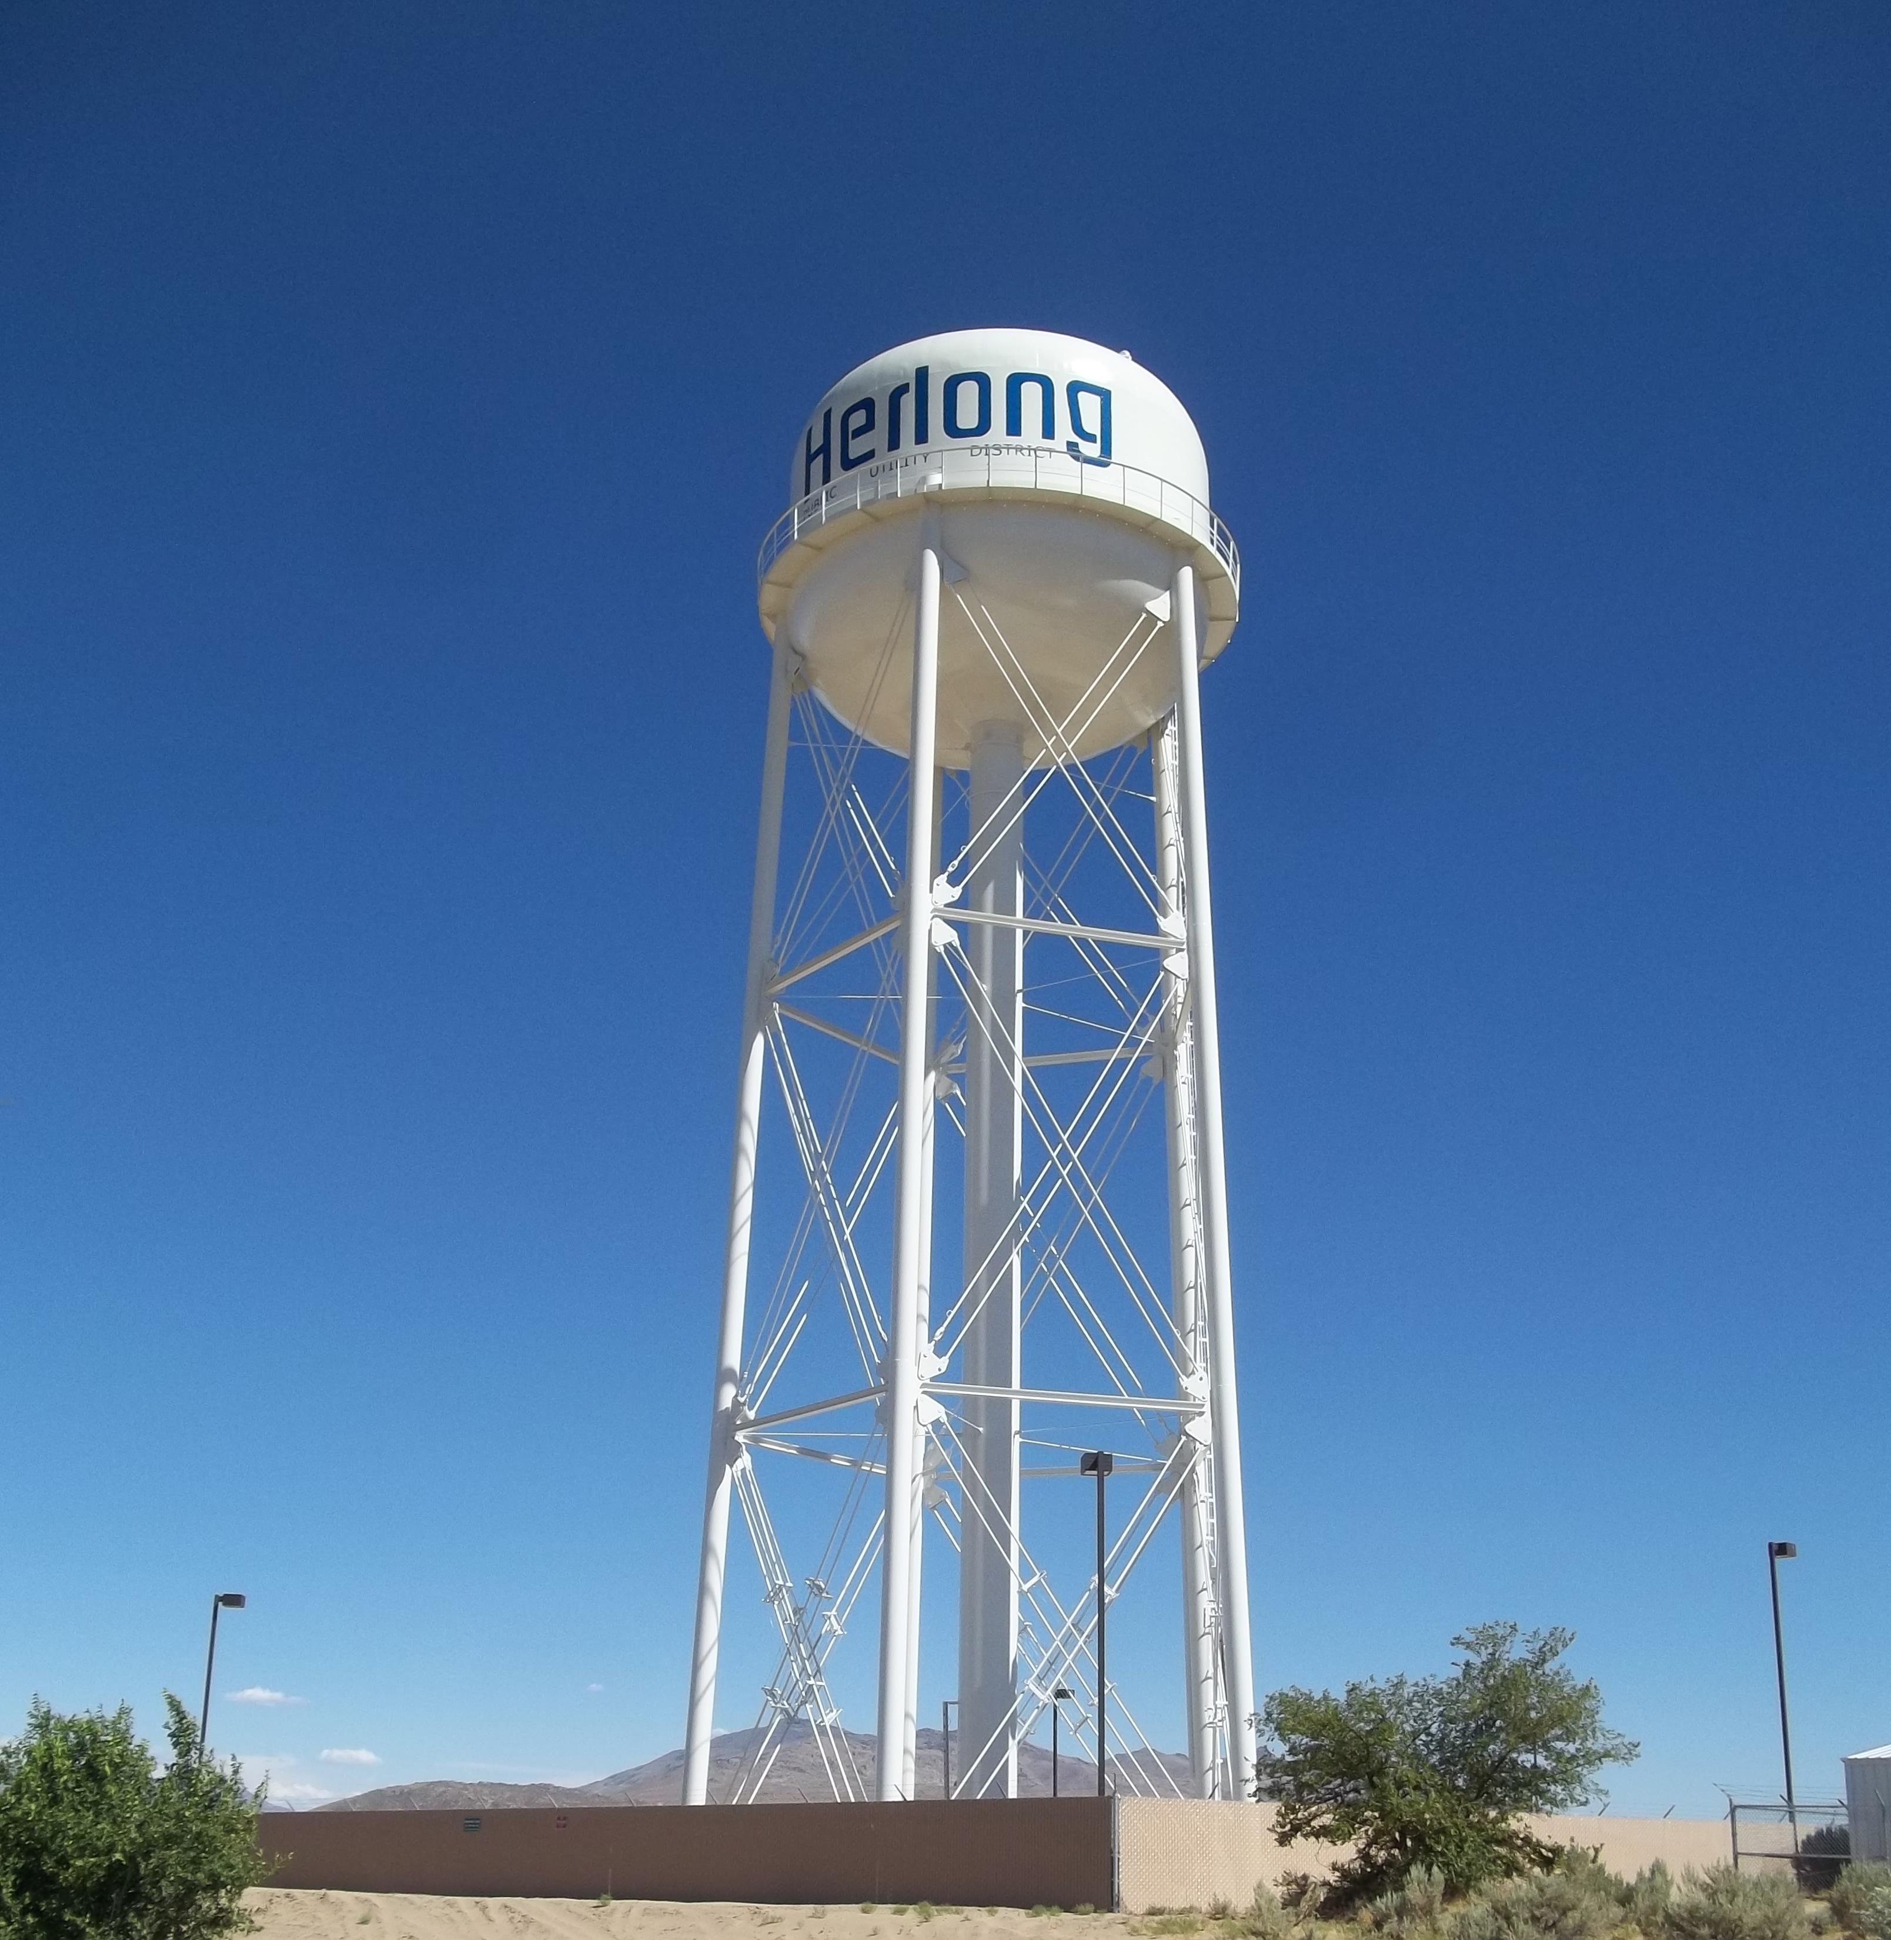
  Herlong Public Utility District
    - it’s RIGHT from the TAP!

HOW TO FILE A PROTEST

NOTICE OF PUBLIC HEARING  PROPOSED WATER & SEWER RATE INCREASES FOR 2026-2030  As part of our ongoing commitment to providing reliable and high-quality water and/or sewer services, Herlong Public Utility District has determined the need for a water and sewer utility rate increases. This is necessary to address the increasing cost associated with the operation and maintenance of public water and sewer systems, as well as the construction of new and replacement water and sewer utility infrastructure.  Herlong PUD engaged Robrt D Niehaus, Inc. (RDN), through California Rural Water Association to complete a water and sewer rate study. The RDN 2024 Water and Sewer Rate Study is the written basis for and supports the proposed rate increases, and the District's Board of Directors has accepted the study results. The Board is considering the proposed rate changes as outlined in this mailing. The complete RDN study is posted at herlongpud.com for review and will be mailed to any interested party upon request.  Notice is hereby given that the Board of Directors of the Herlong Public Utility District is considering the proposed water and sewer rate Increases for 2026-2030. The District Board of Directors will hold a public hearing and receive public comments:  Date: Tuesday, November 18, 2025  Time: 5:30pm, or as soon thereafter  Place: 447-855 Plumas Ave, Herlong Ca  COMMUNITY MEETING: October 22, 2025  @ 5:30 pm @ 447-855 Plumas Ave, Herlong, Ca |  |  | This notice has been sent to all District Property owners receiving water and/or sewer services. You are invited to participate during the public hearing, submit written protests prior to the public hearing, and/or submit written objections by 4:00pm on November 10, 2025, to the District. You can mail your protests or objections to PO Box 115 Herlong, Ca 96113 or you can drop them off in person at 447-855 Plumas Ave, Herlong, Ca 96113  WATER RATES: PER 2000 GALLON  (CURRENT RATE IS $ 2.00 PER GALLON)  Proposed Rates:  RESIDENTIAL WATER RATES:  (CURRENT FACILITY FEE IS $ 84.03)  Proposed Rates:  WASTEWATER RATES:  (CURRENT RATE IS $ 65.62 PER MONTH)  Proposed Rates:  SIRCO water and/ or sewer rates are the same as all residential water rates. SIRCO has the choice to continue to pay the Debt Service/ CIP portion of the water and sewer and only pass the water per gallon and/ or facility charge to their residents, which is as follows: |  | HOW TO FILE AN OBJECTION | NOTICE OF PUBLIC HEARING:  Parties that wish to preserve their right to legally challenge the new water and/ or sewer rates must submit a timely written objection by 5:00pm on November 10, 2025. Prior to the public hearing on November 18, 2025, the District’s Board of Directors will review written objections and determine whether (1) amendments or clarifications are necessary; (2) to modify the proposed new rates; (3) to review further prior to making a determination; and/or (4) to proceed with the public hearing. Additional details on submitting a written objection can be found on Herlong PUD website.  Pursuant to Government Code section 53759.1, any person or entity who may wish to challenge any new, increased, or extended rate adopted, modified, or amended by the District pursuant to this Notice must first exhaust administrative remedies. To exhaust administrative remedies, you must do the following:  - Obtain a written objection form at Herlongpud.com and complete all portions of the form. Oral objections will not be considered. Written objection forms will be mailed or emailed to any interested party upon request by contacting the District’s office at (530) 827-3150.  - Timely submit, either by mail or via hand delivery, the completed written objection form with an original signature by 5:00pm on November 10, 2025 to the District at 447-855 Plumas Ave, Herlong, Ca 96113. Mailed objection forms must be received (not postmarked) by 4:00pm on November 10, 2025. A separate objection form must be filed to object to the proposed new water rates or to the proposed new sewer rates.  Late-filed, non-compliant, or incomplete written objections without an original signature will not be considered as satisfying the exhaustion of administrative remedies requirement. All substantive and procedural requirements for submitting a written objection form are set forth in this Notice and the written objection form.  Failure to timely object, or failure to submit a completed objection form as required above, bars any right to challenge the proposed new rates through a legal proceeding.
  2026 | 2027 | 2028 | 2029 | 2030
  $ 2.38 | $ 2.50 | $ 2.58 | $ 2.67 | $ 2.75
  2026 | 2027 | 2028 | 2029 | 2030
  $ 73.09 | $ 76.19 | $ 79.59 | $ 82.97 | $ 86.24
  2026 | 2027 | 2028 | 2029 | 2030
  $ 64.34 | $ 67.56 | $ 70.93 | $ 74.48 | $ 78.21
  2026 | 2027 | 2028 | 2029 | 2030
  $ 30.98 | $ 34.08 | $ 37.48 | $ 40.86 | $ 45.38

